|  |  |
| --- | --- |
| Term | Fall 2021 |
| Professor | Marc Gurwitz |
| Course Code | SYD366 |
| Course Section letter | D |
| Date of test | December 9, 2021 |
| Time allowed to complete | 36 hours |
| Weight of test | 30% |
| Total marks for the test | 102 |
| Exam Peer Reviewer Name  & Comments | Cindy Laurin, Mehrnaz Zhian, Tevin Apenteng, Azer Karadag |

|  |
| --- |
| **Instructions**  Please read the case study and answer the questions below. This document, in its .docx format must be submitted to Blackboard before the due date along with the source .vpp file. Please note that submitted work in any other format will not be graded.  You are welcome to use additional tools (such as Visual Paradigm) as long as you copy pictures of your work into this document and include your source files. The screenshots must be legible. Your professor will not grade any work that isn’t easy to read.  You are welcome to use outside sources in formulating your answers. Be sure to reference your work using APA format. ***Work not properly referenced will be passed to the Academic Integrity Committee for review.***  Please note that this test is divided into two parts: Sales and Scheduling. Please utilize the provided case study to answer the question in the Sales part of the test and your Week 10 Scheduling Activity to answer the Scheduling part of the test. |

I will be available during our scheduled class times and during posted online office times. If you need to meet outside of these meetings, please contact me via email and we will set something up.

If you are a student with an accommodation and I have received a current accommodation letter from Counselling and Accessibility Service then I will follow the accommodations listed where able. If you have any questions or concerns please reach out to me.

**Part 1: Sales**

**Case Study**

*GetFit Fitness Centres* is a small chain of exercise and training centres throughout Ontario. They operate locations that offer weight training, exercise classes such as Zumba, spinning, and aerobics. They sell monthly and yearly memberships, and also offer a range of branded merchandise, such as t-shirts, water bottles, and other workout gear.

Each location manages their sales by using the automated reports from the debit and credit card machines. Every evening after the location closes, they take the daily merchandise sales reports from the debit and credit card machine and scan them into their computers. These reports do not include enough information to properly keep track of each item’s sales.

The company would like to purchase software to help manage sales of merchandise. They would like the software to enable them to easily sell branded products, both online and in person. Your team has been hired to document GetFit’s requirements and recommend software for them to purchase.

Your team leader has written the following scenario to capture some of *GetFit Fitness Centres’* salesrequirements. The following use case outlines the document that will be emailed to fitness centre members when a sale is complete.

|  |  |  |  |
| --- | --- | --- | --- |
| Use Case Name | Create Sale | | |
| Triggering Event | Customer has chosen the items they wish to purchase | | |
| Brief Description | This use case enables the desk staff to record a sale of items for a customer. Customers who are members of the exercise centre receive a discount, too! | | |
| Actors | Desk Staff | | |
| Related Use Cases |  | | |
| Preconditions | Desk Staff is logged into the system, system is displaying the main menu. | | |
| Post Conditions | Sale is saved to the database and emailed to the member | | |
| Flow of activities | **Actor** | | **System** |
|  |  | Requests to create a sale. | Starts a new sale.  Requests the user’s employee number |
|  |  | Enters employee number. | Assign employee to sale.  Requests member’s phone number |
|  |  | Enters member’s phone number | Assign the member to sale.  Displays the member’s full name.  Displays a list of all merchandise items. |
|  |  | Selects an item. | Displays the colour and size options for that merchandise item and prompts to choose a colour and size. |
|  |  | Chooses colour. | Adds item with its selected colour and size to the sale. Displays the full sale with on-going total price. |
|  |  | Repeats above 2 steps until all items have been added |  |
|  |  | Chooses to email. | Calculates a unique sale number and adds it, along with today’s date to the sale.  As the customer is also a member of the centre, a 10% discount is applied.  Calculates the HST and final total.  Saves the sale and all sale details.  Displays the complete sale.  Emails a copy of the sale to the member. |
| Exception Conditions | Desk Staff chooses to cancel creating the sale. | | |

Question 1 (15 marks)

Create a class diagram that supports the above scenario.

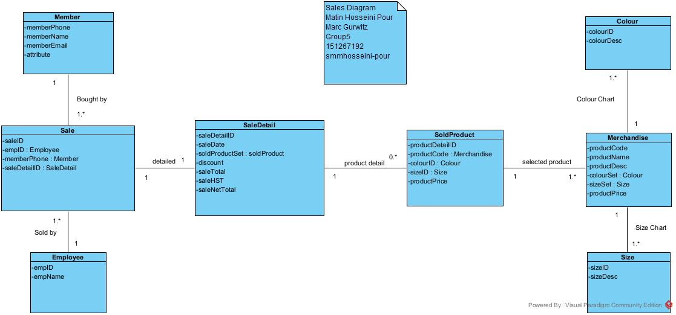

Question 2 (30 marks)

Complete an object-level sequence diagram to support the above scenario.

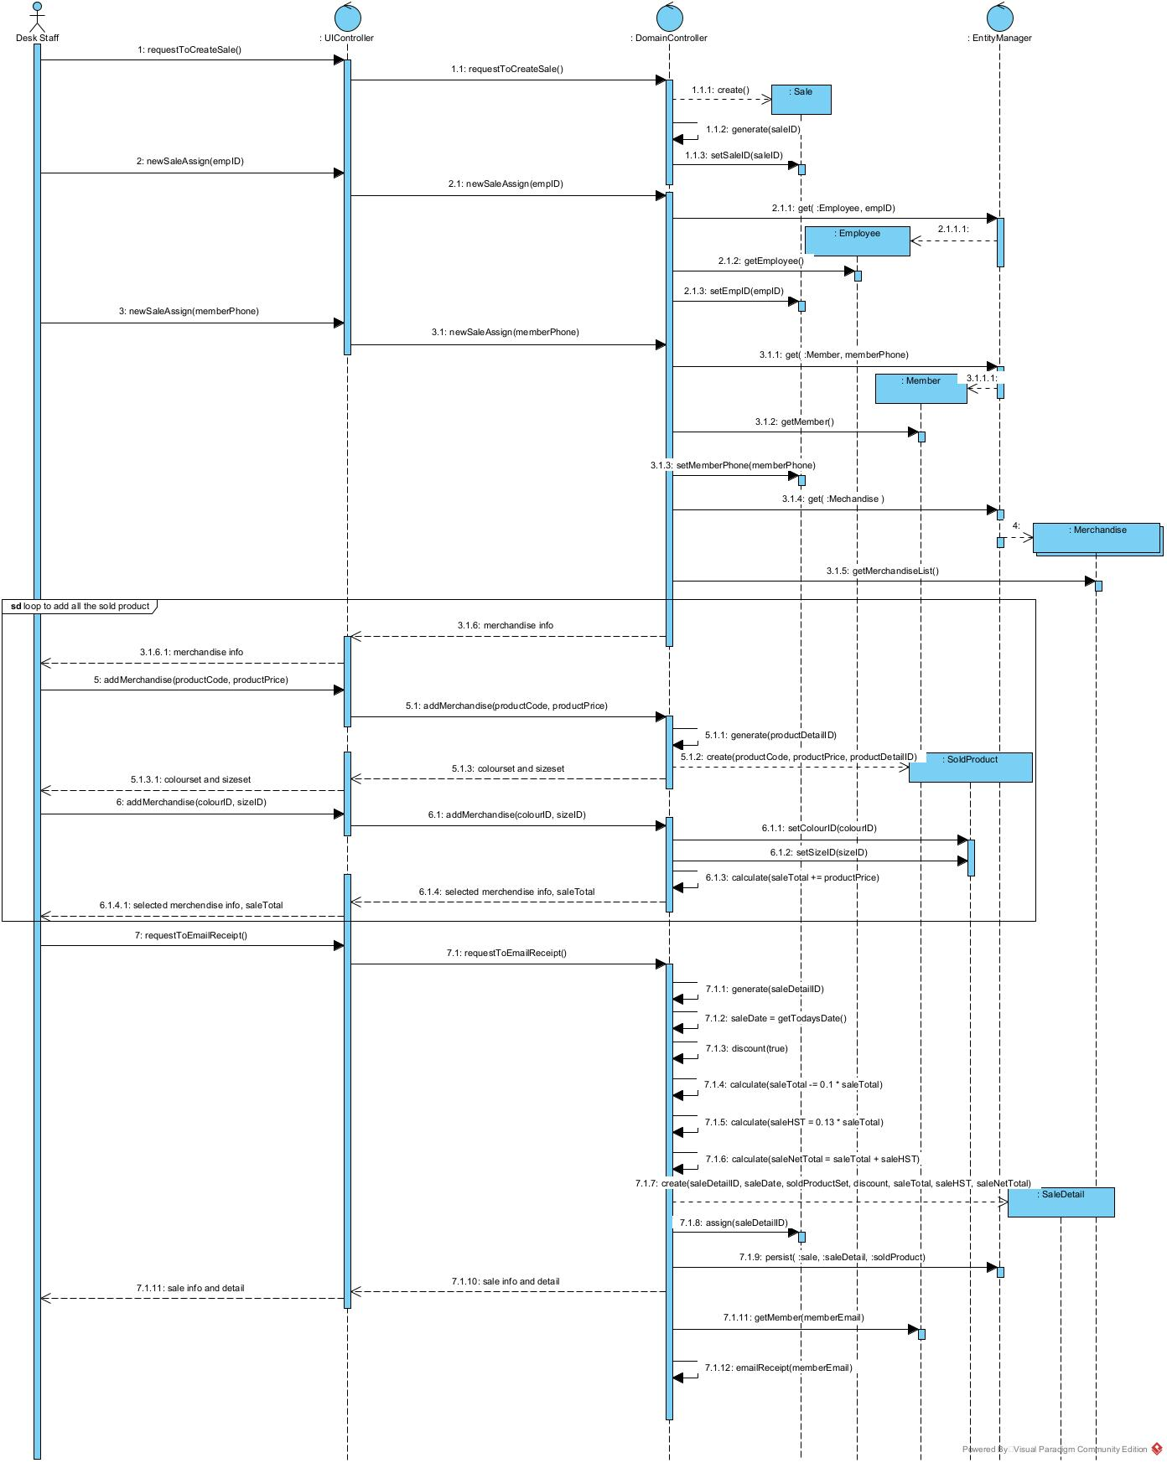

Question 3 (6 marks)

The above scenario assumes that each item purchased in a sale is unique, but what if a customer wants to purchase multiple items that are exactly the same? Does your model support set quantities? If not, how would your change your model? Please describe in English.

Currently my system does not support quantity and even if they order a same thing multiple times, they have to add that over and over.

In order to change the system to support that I have to add ‘quantity’ and ‘total price’ attributes in to the soldproduct class. So when they add the quantity the system would calculate totalprice=quantity*productprice.

And then I will sum them up in the saleDetail for the net total and hst.

Question 4 (6 marks)

*GetFit Fitness Centres* is thinking of offering a ‘buy one, get one at half-price’ program to help sell older merchandise. Does your model support this? If not, how would you change your model? Please describe in English.

My system definitely does not support this scenario. For this scenario I can add a Boolean attribute into the soldproduct as ‘half price’ so when a customer gets something, half price for that particular item would become true and only if there was another product with the exact same productCode the system would apply the 50% off and half price would be set as false again.

In case at that time my system supported quantity scenario I don’t need the Boolean anymore I would just easily divide the quantity by 2 and the take the whole integers out of the decimal and multiply by the productprice and then take the half off.

Explanation:

If customer buys five of a product. Then 5/2 ~= 2 then totalprice - ( 2 * productprice * 0.5)

Ps. In quantity scenario we have totalprice in the soldproduct class.

**Part 2: Scheduling**

You participated in a scheduling activity as part of Week 10’s in-class group activity. Please use that activity in its entirety as the background case study for this part of the test.

Your team leader has written the following scenario to capture some of GetFit’s requirements. The following use case outlines how a trainer will review their work schedule for the upcoming week.

|  |  |  |  |
| --- | --- | --- | --- |
| Use Case Name | Query Schedules | | |
| Triggering Event | One of the trainers wants to see their schedule for the current month. | | |
| Brief Description | Allows a trainer to request their scheduled classes for the current month. They will be able to see their assigned classes with respective start times and end times, the room(s) that they are using, and intensity level of the class. | | |
| Actors | Trainer | | |
| Related Use Cases | Create Schedule | | |
| Preconditions | Trainer is logged in and the system is displaying the Employee Menu | | |
| Post Conditions | Class schedule is displayed to the trainer. | | |
| Flow of activities | **Actor** | | **System** |
|  | 1. | Requests schedule | Uses login information to retrieve and display schedule for the trainer for the current month, including classes, rooms, and start and end times. |
| Exception Conditions | Trainer chooses to cancel retrieving their schedule | | |

Question 5 (30 marks)

Create a class diagram that supports the above scenario.

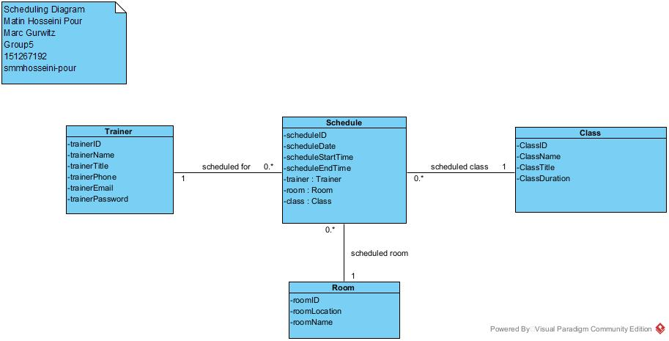

Question 6 (15 marks)

Complete an object-level sequence diagram to support the above scenario.

